Venerator class:
During first Tier, the caster may gain 1 random “Bonded” Personal Ancestor contact per level up to a maximum of four. Each Ancestor has a distinct personality, class, and era of life. Upon attaining a new Tier thereafter, one contact of the caster’s choosing may be dropped in exchange for a random new contact (possible spell to increase chance of “directing” it towards a specific class or higher level.) The Ancestors are rolled up by the GM as an NPC but will have less direct influence on the party than an actual NPC would.
The GM gets to pick the personalities and their cooperativeness. It is strongly recommended the GM ensure there is at least one cooperative personality within the group of ancestors the player character has access to.
The ancestor need not share all of the details from their life unless the GM so desires. However, the caster may obtain information from them on a case-by-case basis through commune spells. Questions regarding information closer to the ancestor’s class/race is easier to obtain while more esoteric info/languages require higher level spells and have a lower chance of success. (See “Commune with Ancestor” below)
Some of their spells invoke local spirits that inhabit places. The caster may build a small simple shrine that gives a bonus within a certain radius or small geographic area (e.g.-a cave.) Or call upon a local spirit to do damage or distract an enemy.
Only one shrine per area may be built. If one already exists, it allows the GM to predetermine the effect. Destroying a shrine angers the spirit it was dedicated to. The spirit might damage the party and definitely would not provide aid.
Commune Spells:

Petition Ancestor Commune:1st level
Rollout: one day
A 10’ globe of bright light appears around the caster 30 minutes into the rollout and stays for the duration of the Commune.
If the caster does not have 4 established Ancestor contacts, they may choose to create a new contact with a random ancestor of theirs. But selecting an additional Ancestor connection can only be done once per level. Therefore, by 4th level all four Ancestor slots could be filled up.
A successful MR save creates a new established Ancestor connection.

Commune with Ancestor: 5th level
1 hour rollout.
A 10’ globe of bright light appears around the caster 30 minutes into the rollout and stays for the duration of the Commune.
Caster conducts a ceremony and communicates with an established Ancestor. Only one Ancestor may be contacted during this spell.
This spell allows the caster to ask questions about events and things from the Ancestors era. The Ancestor may answer questions about events they were involved in or languages they know. This Direct Ancestor Knowledge may be accurate, inaccurate, or partially accurate. GM assigns a caster Skill save adjusment based on the difficulty of the question asked.

Ancestor Delving Commune: 8th level
Rollout: 1 hour, Requires focus item.
A 10’ globe of bright light appears around the caster 30 minutes into the rollout and stays for the duration of the Commune.
The Ancestor “may” be able to answer questions outside their Direct Ancestor Knowledge, but it requires “delving” on their part. Upon being asked to delve for a single answer, the ceremony ends. The caster may commune only with the delving Ancestor until they receive an answer or request an end to the delve. Petition Ancestor and Channel Ancestor spells will not work during a delve.
Delves are limited to knowledge from the Ancestors Era and are subject to the same limitations as Direct Ancestor Knowledge, but with more difficult saves.
Delving saves are based on the caster’s Skill simplest questions and rise (via adjustments) from there. The GM determines the difficulty when the question is asked. The player will not be told the roll results or adjustments directly, but the Ancestor may hint at them. Players are encouraged to limit questions if they want good answers.
The number of days required for the Delve is normally one or two days. The answer will be cryptic or only partially correct If the save is less than 20 points over the save #. The Delve period restarts if the save is failed.

Channel Ancestor Commune: 11th level
Rollout: one day, requires focus item
Caster channels a specific spell for one day from one of their established Ancestors.
The spell is limited to the level of the caster and the Ancestor. If the caster is 11th level and the Ancestor was 15 level, the spell is limited to 11th level. If the Ancestor only attained 6th level, it would be limited to 6th level spells. No other commune spells may be cast while Channeling.

Possessed by Ancestor Commune: 15th level
The Ancestor takes control of caster’s body. Possession means the Ancestor is able to share the casters body with the caster. Thus the Ancestor is able to use skills and spells they have mastered. However, the caster is still in the body along with the Ancestor, therefore the casters level must be taken into consideration as a spell/skill level limitation. The ancestor is limited to the player character stats and the Ancestor may only use up to 1/3 of their spell/skill points and still have the Venerators HP. The player still runs the character but uses the Ancestor class and skills. Would include a Nae’Em like connection since they are in the same body.

Shrine Spells: (general suggestions, various levels)
10-minute rollout to construct a simple shrine from scratch (pyramid of rocks, assemble precut small boards, that sort of thing.
Prebuilt shrines take 1-10 rounds to set up.
Shrines gain assistance from local spirits or Kami. Effects are generally non-battle, when they do affect battle, they affect both friend and foe.
Shrines are creations that will be purchasable or build-able but give greater effect when a Venerator sets up.
- Greatest Benefit will be when a Venerator builds a shrine from scratch from local materials though some spells may require specific materials. These shrines are by far the most powerful.
- Next Greatest Benefit will be when a Venerator sets up a pre-built shrine.
- Least Greatest Benefit will be when a non-Venerator sets up a pre-built shrine. These shrines are very weak.
Preexisting Beneficial shrines can be subtle up to outright disguised. To receive the benefit characters must pay respect at the shrine (if they locate it.) A second shrine will not work if placed in the same area. Venerators may locate shrines when they actively sense for them.
Possibly obscuring spells like smoke or wind creating dust.

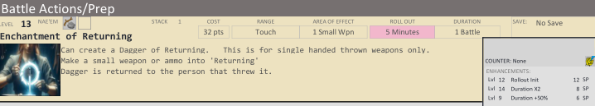
Spirit returns the item to you.
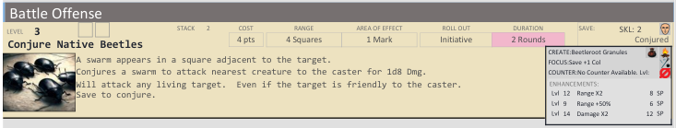

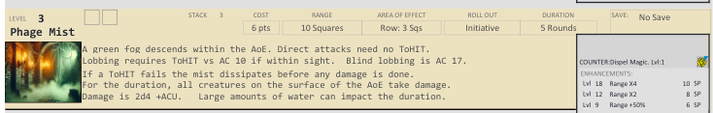
Phage spells longer duration? Damage over time? Damage spell/skill points instead of hp?
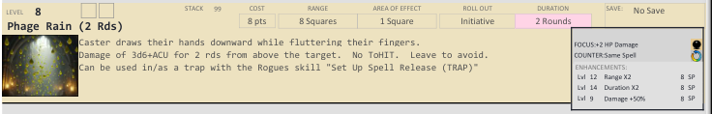
Minimal HP damage with more skill damage?
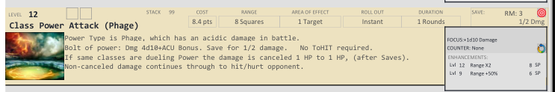
Phage Healing spells? (specifically heals phage damage/dot)
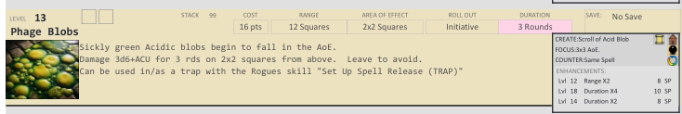

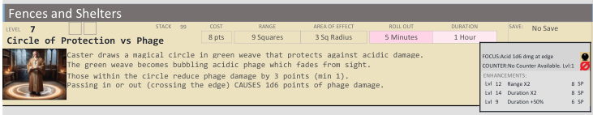

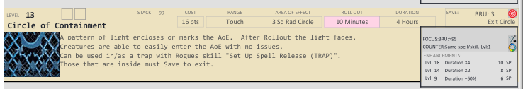
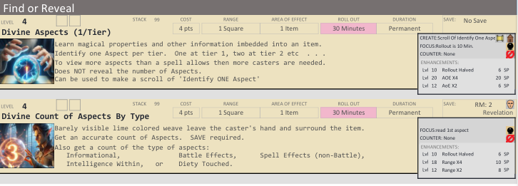

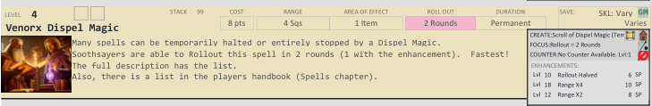

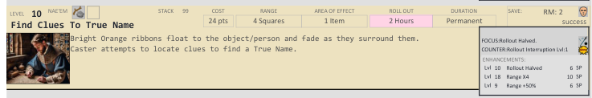
Commune Spell?
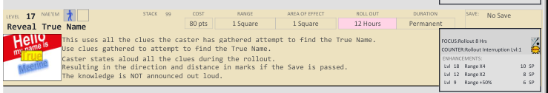
Commune Spell?

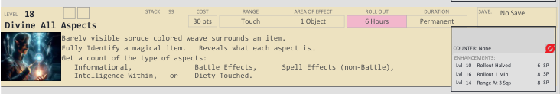

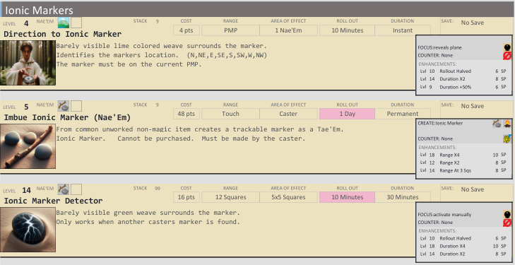
Ionic involves a spirit?
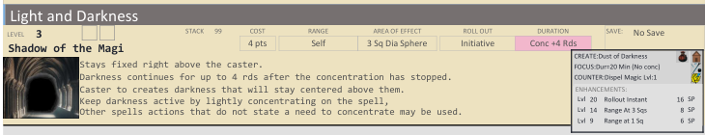

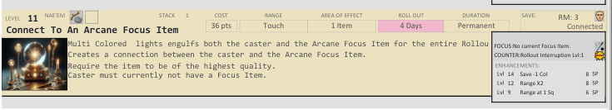

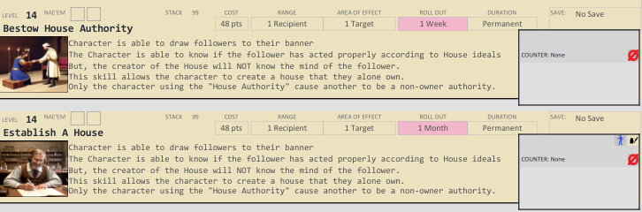

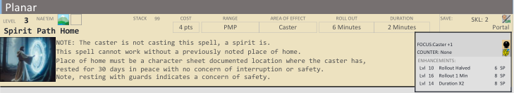

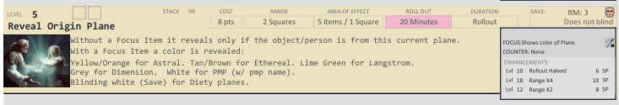
Reveal Origin Plane(Commune Spell)

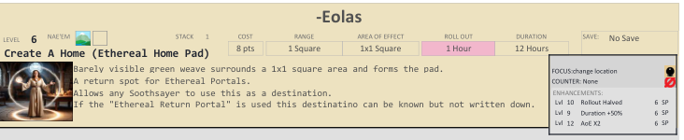

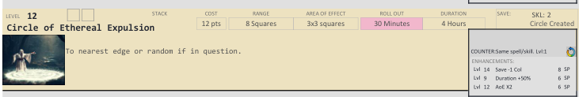

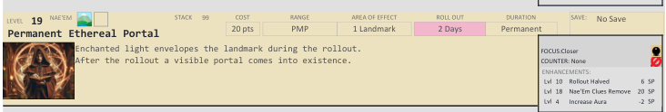

Scrying Spells as Commune spells?
Spell to connect Ancestor to PMP spirit (possibly corrupted by a Necromancer)

